[**Disparities in the Quality of Cardiovascular Care Between HIV‐Infected Versus HIV‐Uninfected Adults in the United States: A Cross‐Sectional Study**](https://www.ahajournals.org/doi/10.1161/JAHA.117.007107)

**Problem Statement:**

Cardiovascular disease is emerging as a major cause of morbidity and mortality among patients with HIV. We compared use of national guideline‐recommended cardiovascular care during office visits among HIV‐infected versus HIV‐uninfected adults.

**Features Selected:**

Firstly, they filtered the data to include only the 40-79 year olds. They included the following features (among others):

1. Causes and Diagnoses (To know which patients have HIV)
2. Patient’s previous visits’ complaints (to identify adverse cardiovascular events).
3. Existing Diseases (coronary artery disease, stroke, carotid stenosis, peripheral vascular disease, and abdominal aortic aneurysm), hypertension, diabetes mellitus, dyslipidemia, obesity/overweight, and cigarette smoking)
4. Age, sex, race/ethnicity, insurance (private, Medicare, Medicaid, self‐pay/no‐charge, and other/unknown), US census region (Northeast, Midwest, South, and West), and urban or rural setting

**Results:**

Below a part of the data can be seen with important statistics. The rest of the diagram can be found [here](https://www.ahajournals.org/doi/10.1161/JAHA.117.007107)

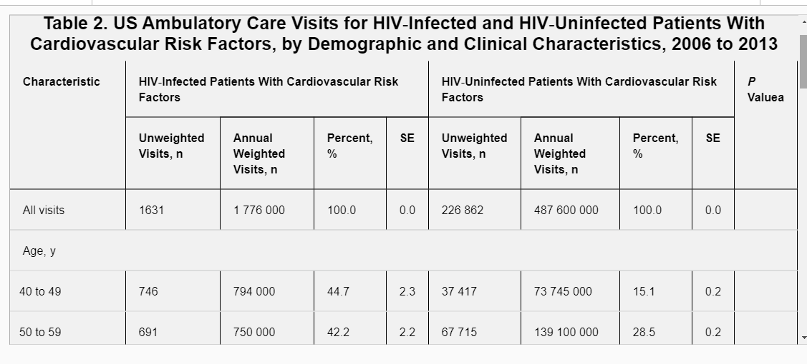

They have not really developed models, but rather started analyzing the data and they looked at statistics etc.